**ParLaur Beauty**

**Full Documentation**

**Final Report**

**ParLaur Beauty Design Team:**

Parveen Kaur

Lauren Hicks

**CSIT-337 Internet Computing**

**Course Section 2**

**Professor John Jenq**

**Montclair State University - Fall 2017**

***Table of Contents***

**1. Contributions...………………………………...……………………………….3**

**2. Project Summary.…………………...………………………………………….4**

**3.  Website Architecture…….…………………………………………………….5**

**4. User Manual...…………………………………………………………………..6**

**5. Program Files...…………………………………………...……………………7**

**6. Database…………………………………....…………………………………..8**

**7. Test Run……………….…………………………….………………………….9**

**Contributions**

Parveen Kaur:

Parveen worked on all the HTML code for the website.

Lauren Hicks:

Lauren worked on the PHP code as well as the database.

We both worked on the finishing touches to make the website function properly. Also, we worked on the final report together.

**Project Summary (Step One)**

Our project mission was to create a website were makeup lovers, like ourselves, can shop for all their favorite brands. We used HTML, CSS, JavaScript, PHP, and JQUERY as languages and MySQL as the backend database. Our website has a log in page that calls to the database were an email and password are stored. There are also products stored in the database.

**Website Architecture**

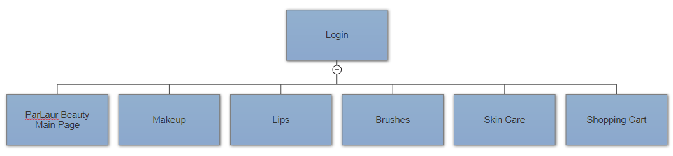

**User Manual**

The first thing the user will do is log in. After the user logs in, it brings them to the main page where some beauty looks are displayed. The next five tabs are where the items are located. The first tab is ‘Makeup’ where all the base makeup is found. Next is ‘Lips’ where lip products are. Then it is ‘Eyes’ where eyeshadows, palettes, and primers are placed. After that there is the ‘Brushes’ tab the had different kinds of makeup brushes. Lastly is the ‘Skin Care’ tab that has different skin care products. There is a small description of what the product is, how much it costs, and an add to cart button. To add an item to the cart, the user can click on the ‘Add To Cart’ button which will bring them to a screen that will display the item number and quantity. The user can change the quantity number here or in the cart view. Once the user clicks the ‘Add Item’ button, it will bring them to the user’s cart. The cart displays the item, quantity, cost, item total, subtotal. The user can also change the quantity in the cart and can click the ‘Update Cart’ to update the cart. There are 3 links that can be clicked; ‘Continue Shopping’, ‘Empty Cart’, and ‘Checkout’. The user can click ‘Continue Shopping’ if they want to add more items to the cart, ‘Empty Cart’ to completely empty the cart, or ‘Checkout’ if they want to make the payment. The payment screen is where the user will input their billing information. Once that is filled out, they can click on the ‘Submit’ and that will take them to the confirmation screen.

**Program Files**

HTML files:

1. beautyPage.html
2. makeup.html
3. lips.html
4. eyes.html
5. brushes.html
6. skinCare.html
7. payment.html

CSS files:

1. website.css

PHP files:

1. Index.php—Login page
2. add_item_view.php
3. cart.php
4. cart_view.php
5. paymentConfirm.php

**Database**

The user that can access our database is:

Username: parlaur

Password: parlaurpass

Import the SQL file parlaurdatabase.sql into a new created database called ‘parlaurdatabase’.

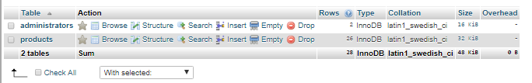

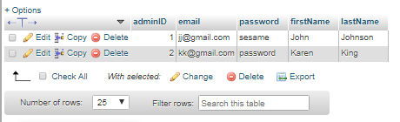

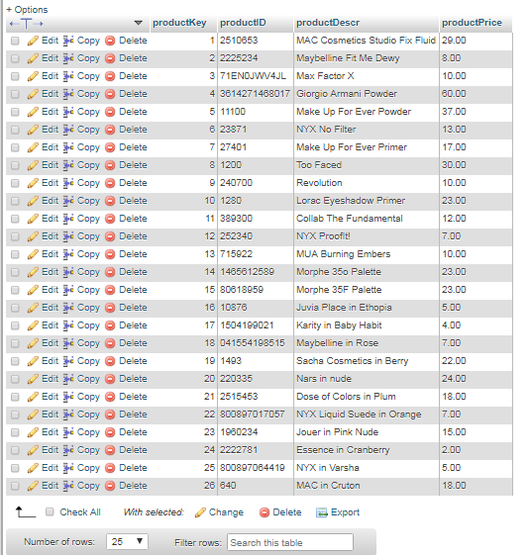

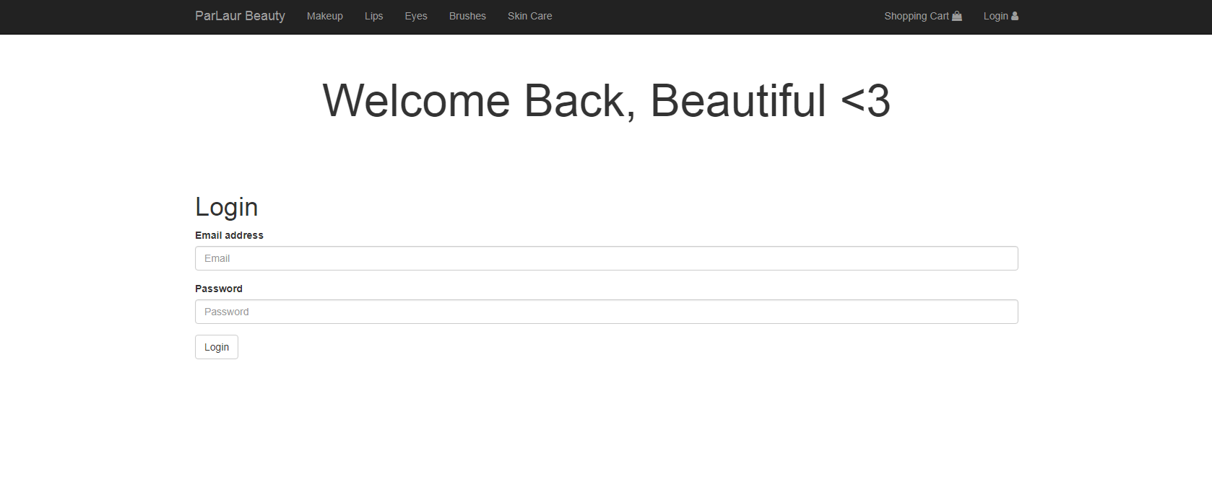**Test Run**

